Applied Databases

Higher Diploma in Science in Data Analytics

Innovation and extra functionality

Part 1:

A function to clear the screen for user after a period of time

*# https://www.geeksforgeeks.org/clear-screen-python/*

*# import only system from os*

*# import sleep to show output for some time period*

*# define our clear function*

*def clear():*

*# sleep(2)*

*# for windows*

*if name == 'nt':*

*_ = system('cls')*

*# for mac and linux(here, os.name is 'posix')*

*else:*

*_ = system('clear')*

*ProjectApp.display_menu()*

Part 2:

A countdown function to display to user when output from choice will clear and return to the main menu

*def countdown():*

*print("\nClearing Data on Screen and Returning to Main Menu in:")*

*for i in range(9,0,-1):*

*# print number to screen then remove*

*print(f"{i}", end="\r", flush=True)*

*# pause program for 1 second*

*sleep(1)*

Part 3:

A function to check if files are present to run the app

* *ProjectApp.py*
* *ProjectAppMySQL.py*
* *ProjectInnovation.py*
* *ProjectAppNeo4j.py*

*# Function to check if all files required for the app are present in the same folder*

*# Assist in debugging for the app*

*def app_checker():*

*# List of Files*

*appfiles = ["ProjectAppMySQL.py", "ProjectInnovation.py", "ProjectAppNeo4j.py"]*

*# Get currrent working directory*

*filelocation = os.path.dirname(__file__)*

*# Use list of file to check if that they are present*

*for file in appfiles:*

*try:*

*# try open file using path and filename*

*# output to screen*

*with open(filelocation + "\\" + file) as f:*

*print("\nProject Apps File Found")*

*print(file)*

*except IOError:*

*# Error if files not found outpur missing file name*

*print("\nProject Apps File Not Found " + file)*

*return false*

*return true*

Part 4:

Logging the application to check if elements are working from the specification sheet (requires command prompt admin level privileges)

This is a great tool in python to log information for troubleshoot the application

All examples below show the output to the logs for each of the examples from the specification sheet

*Program loads required programs. Outputs to logging file*

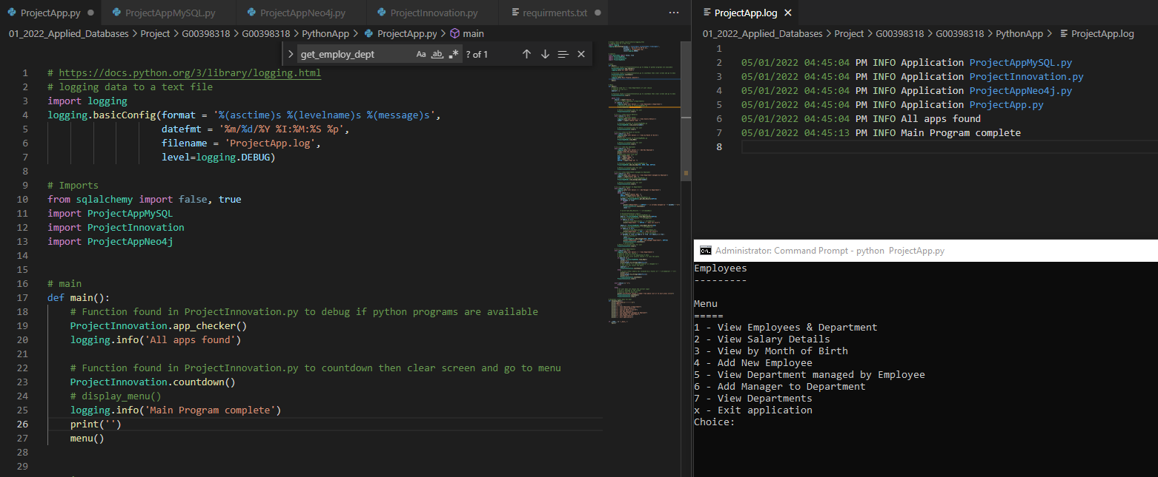

***##############################################################################***

***Select Choice 1***

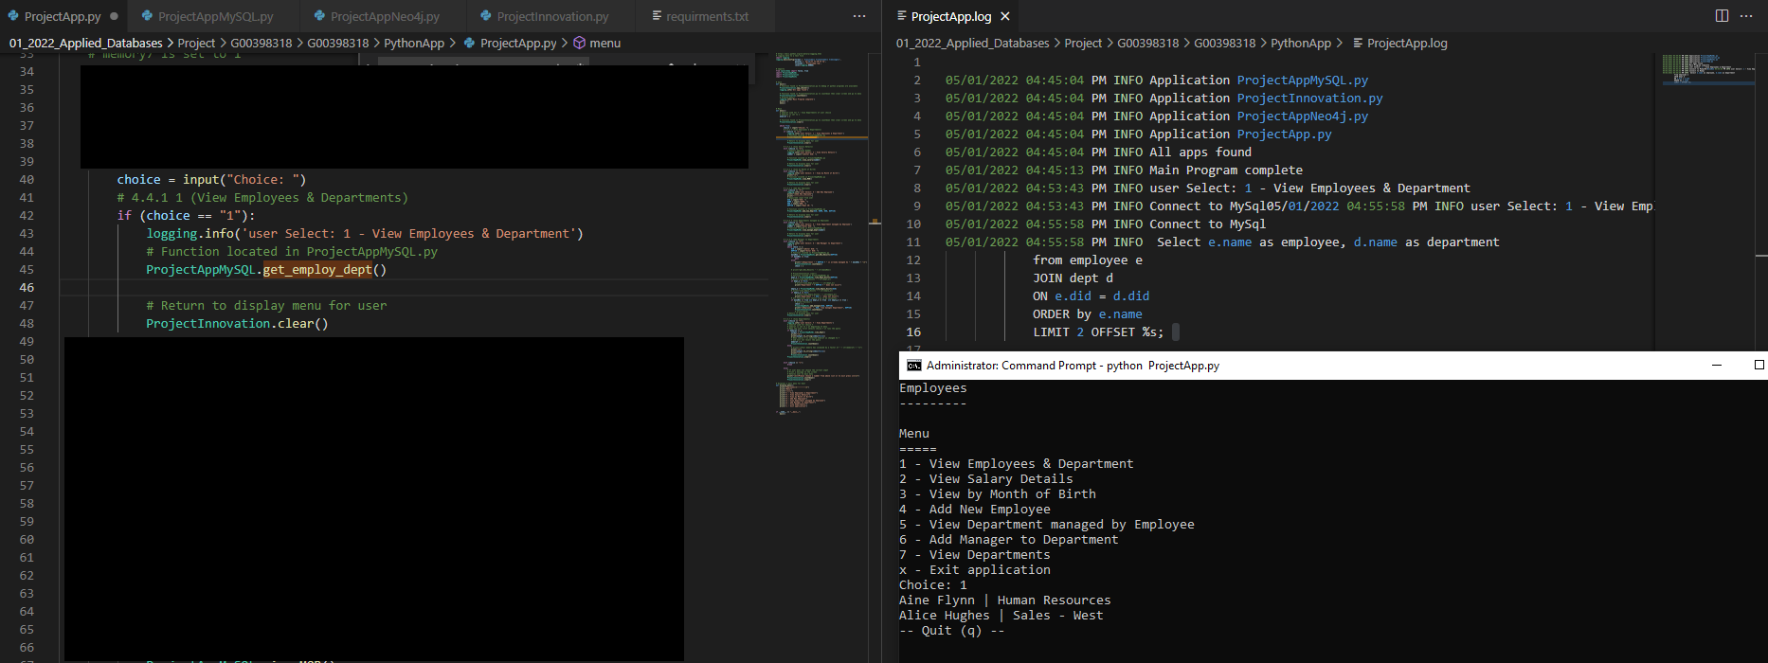

*Query database and q to quit*

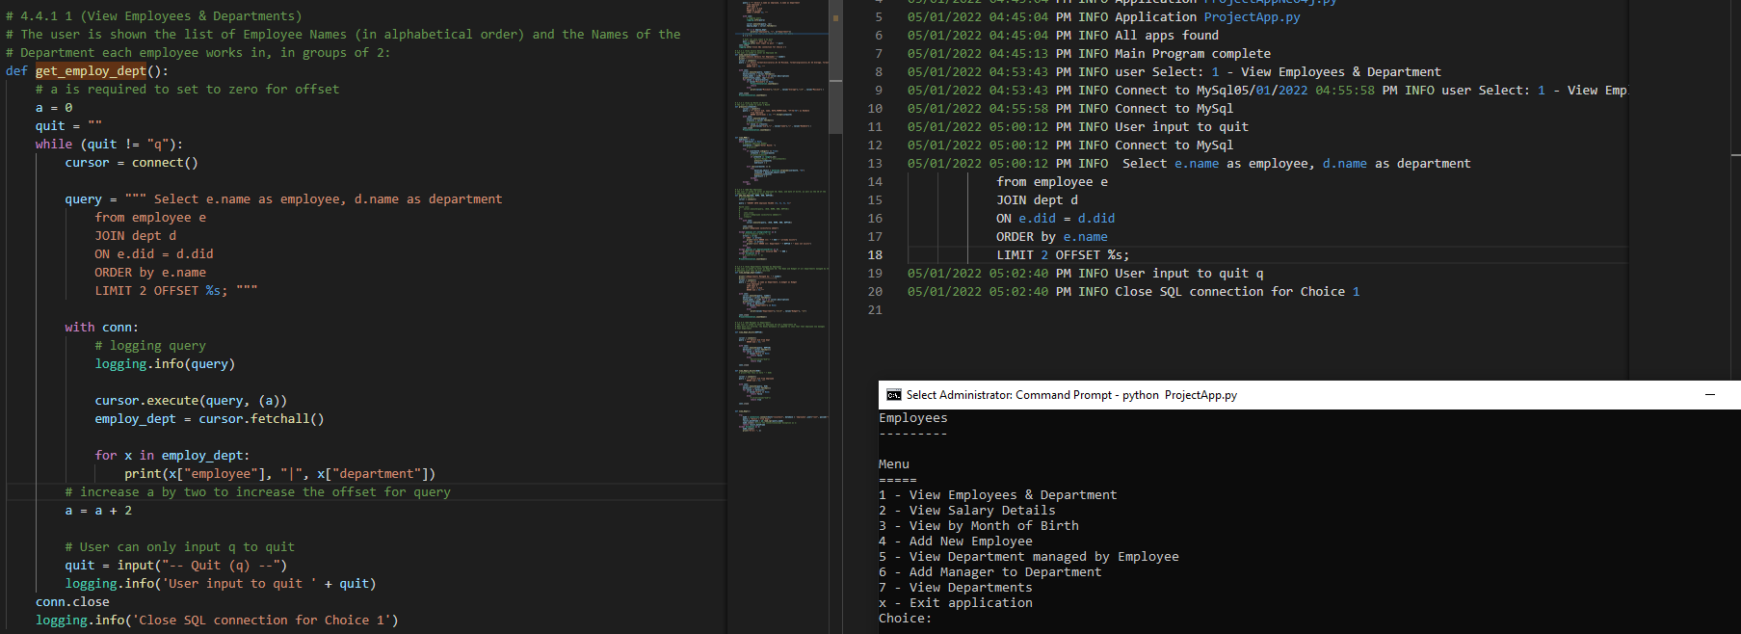

*##############################################################################*

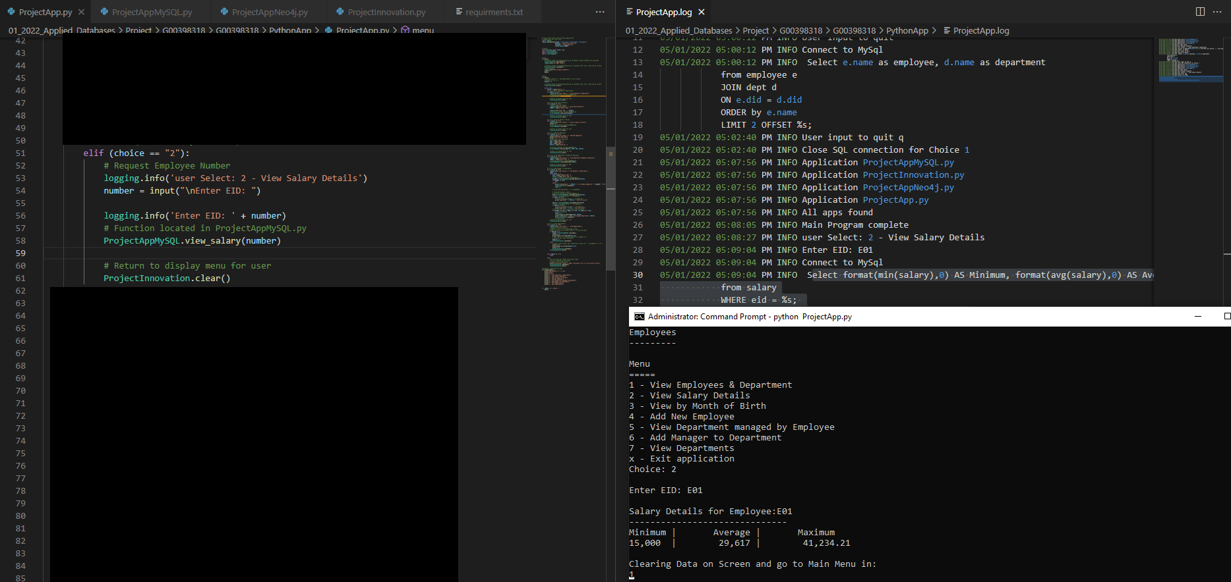

***Choice 2 input with output of salary***

*Records user input if non-existent Employee ID*

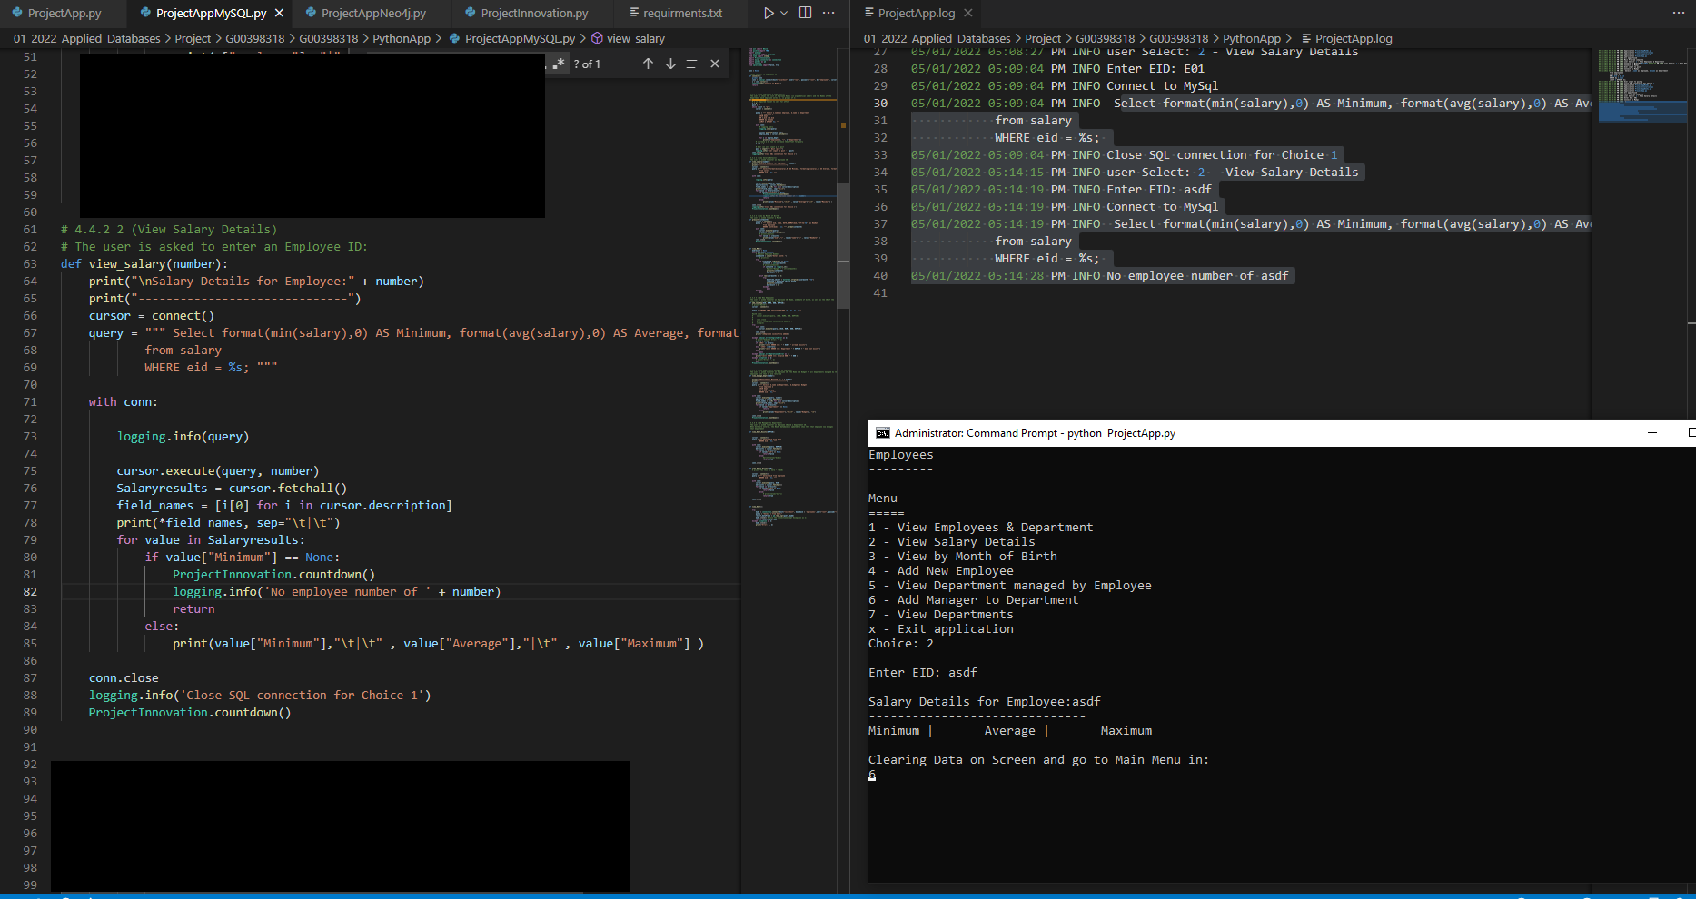

*##############################################################################*

*Choice 3*

*User input incorrect month format def view_MOB()*

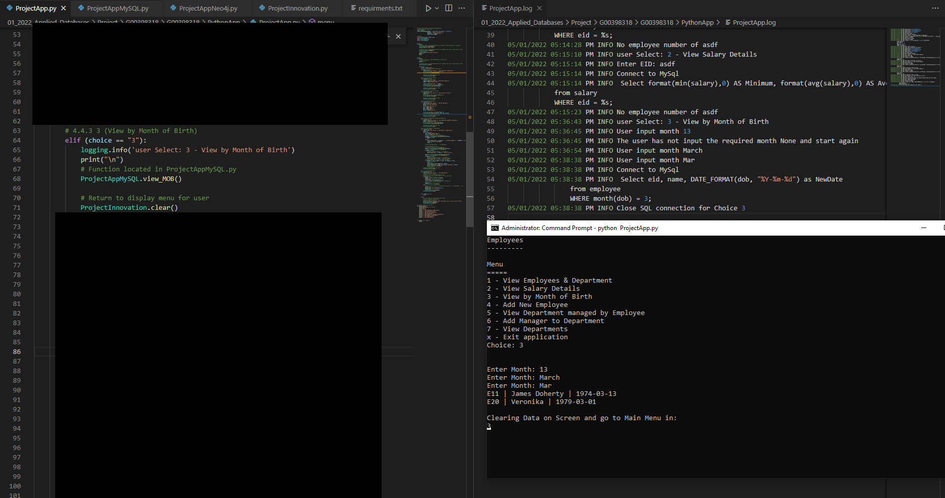

*def view_MOB() test the user input is the correct format for month*

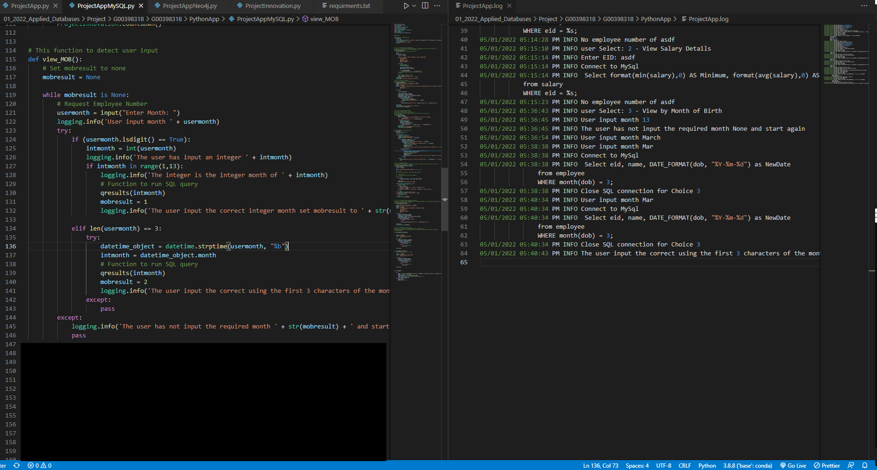

*Input month as aPr*

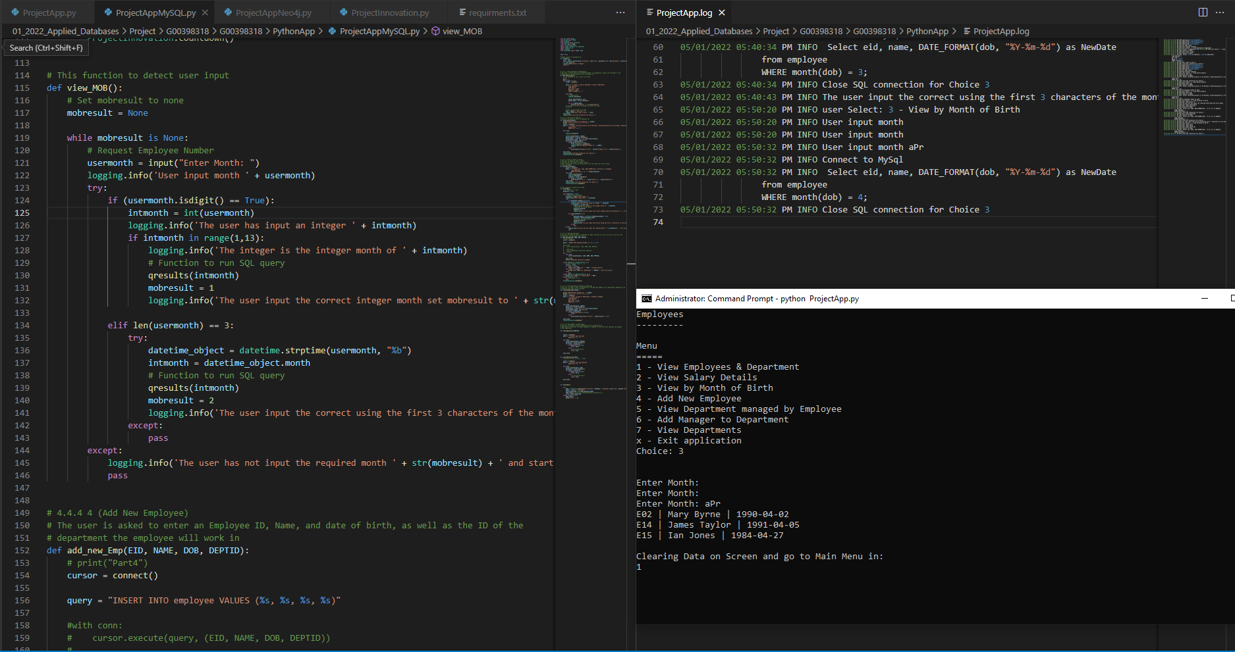

*qresults(intmonth) function is run when user inputs the correct format.*

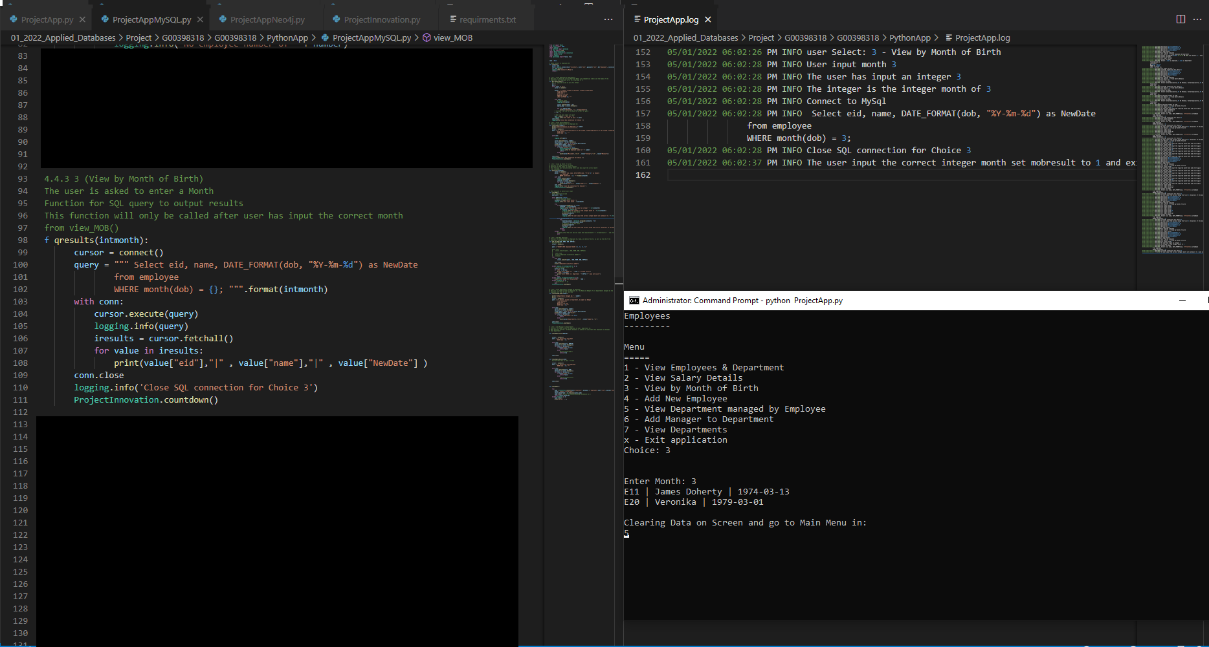

*##############################################################################*

*Choice 4*

*Error on Date*

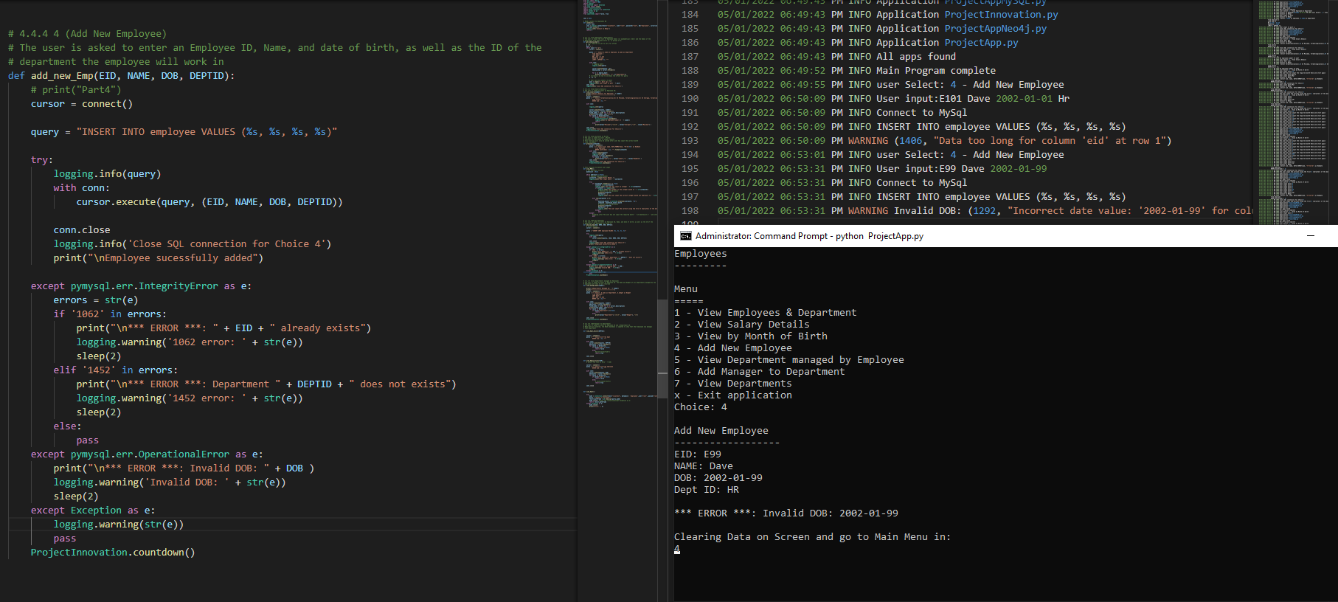

*Error on Department*

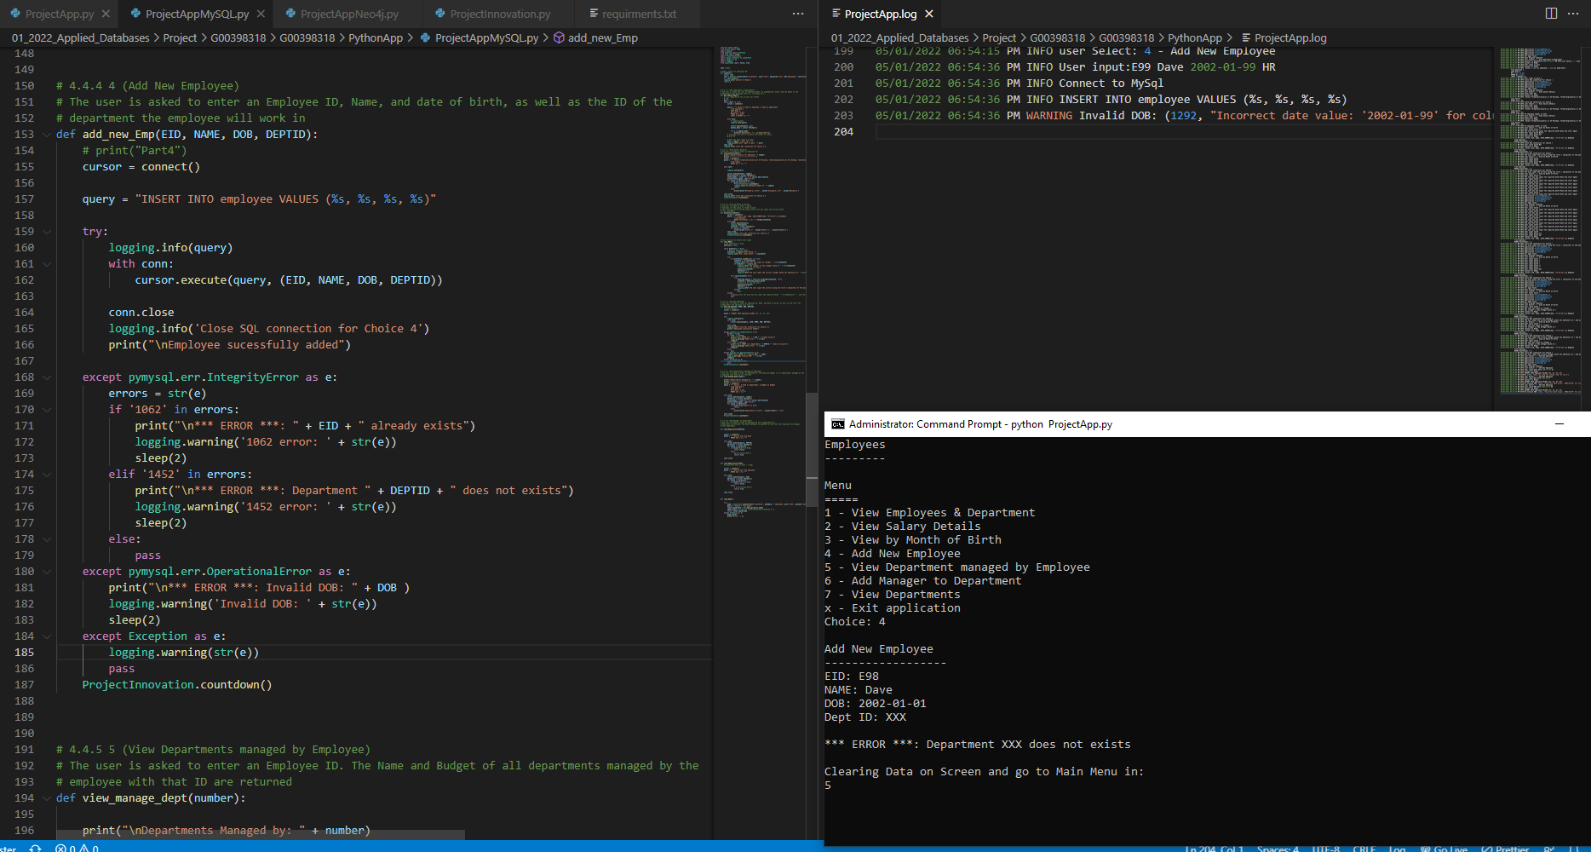

*Error Duplicate Employee*

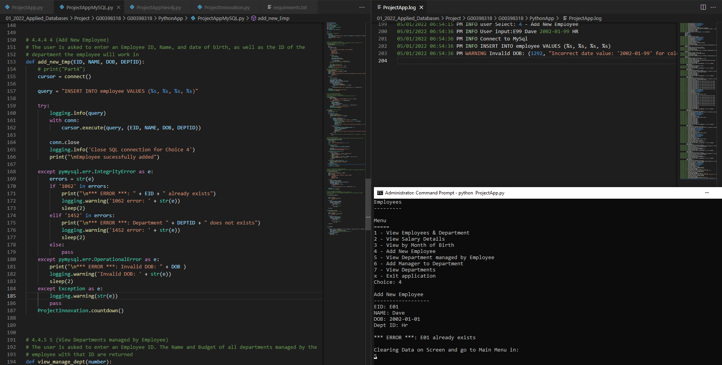

*##############################################################################*

*Choice 5*

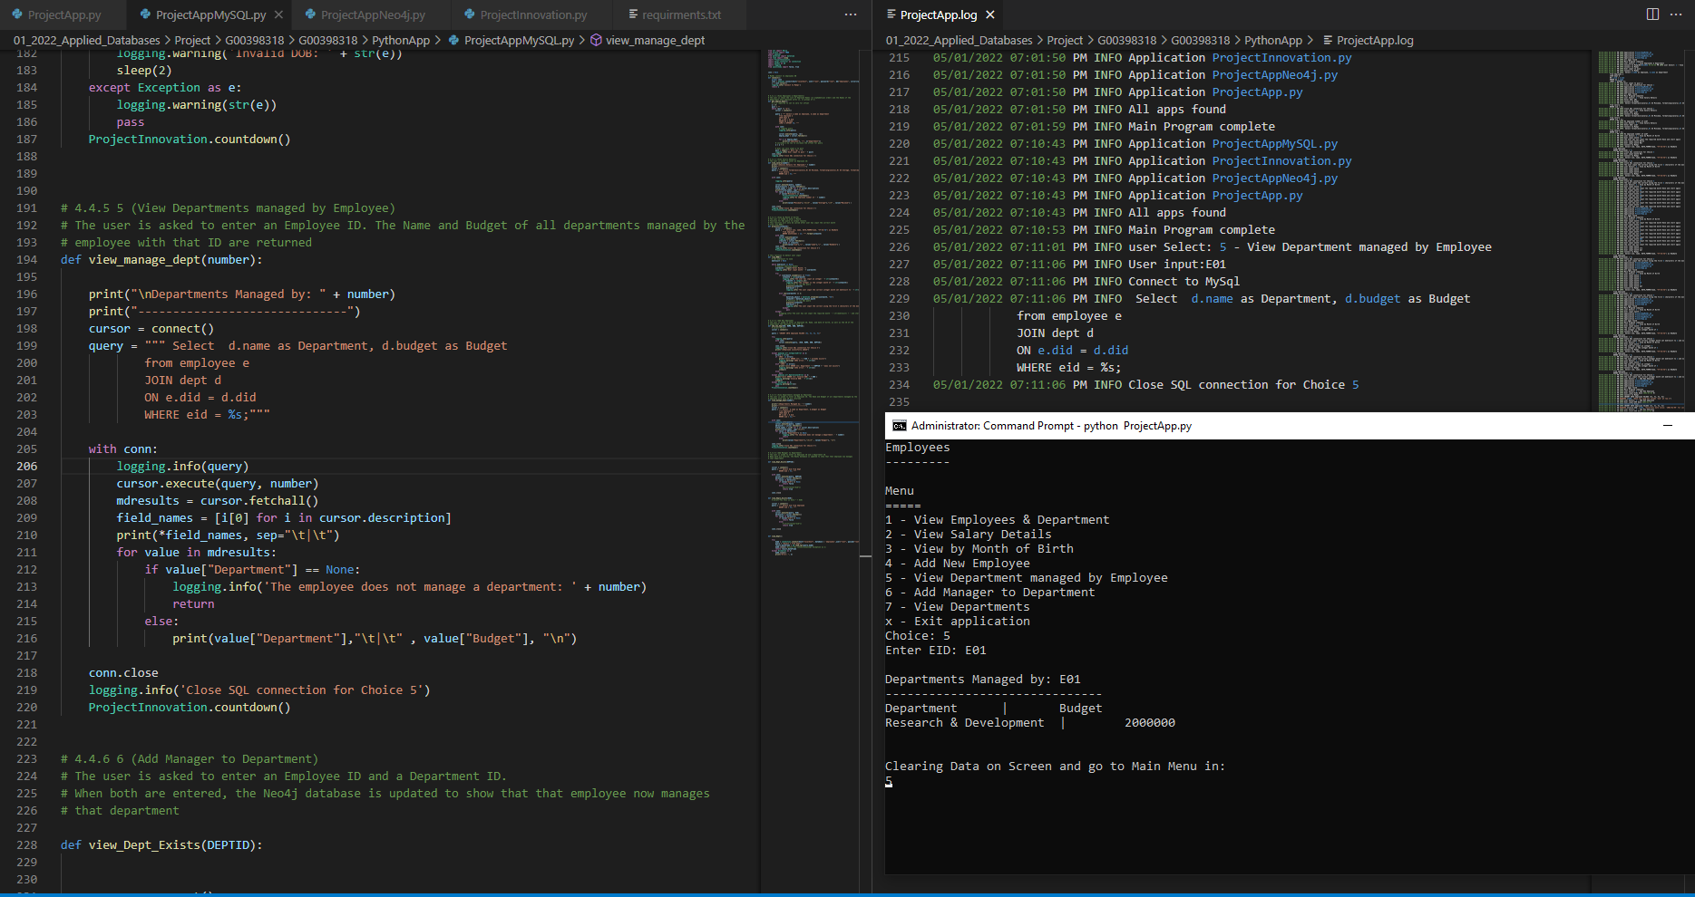

*##############################################################################*

*Choice 6*

*Adding*

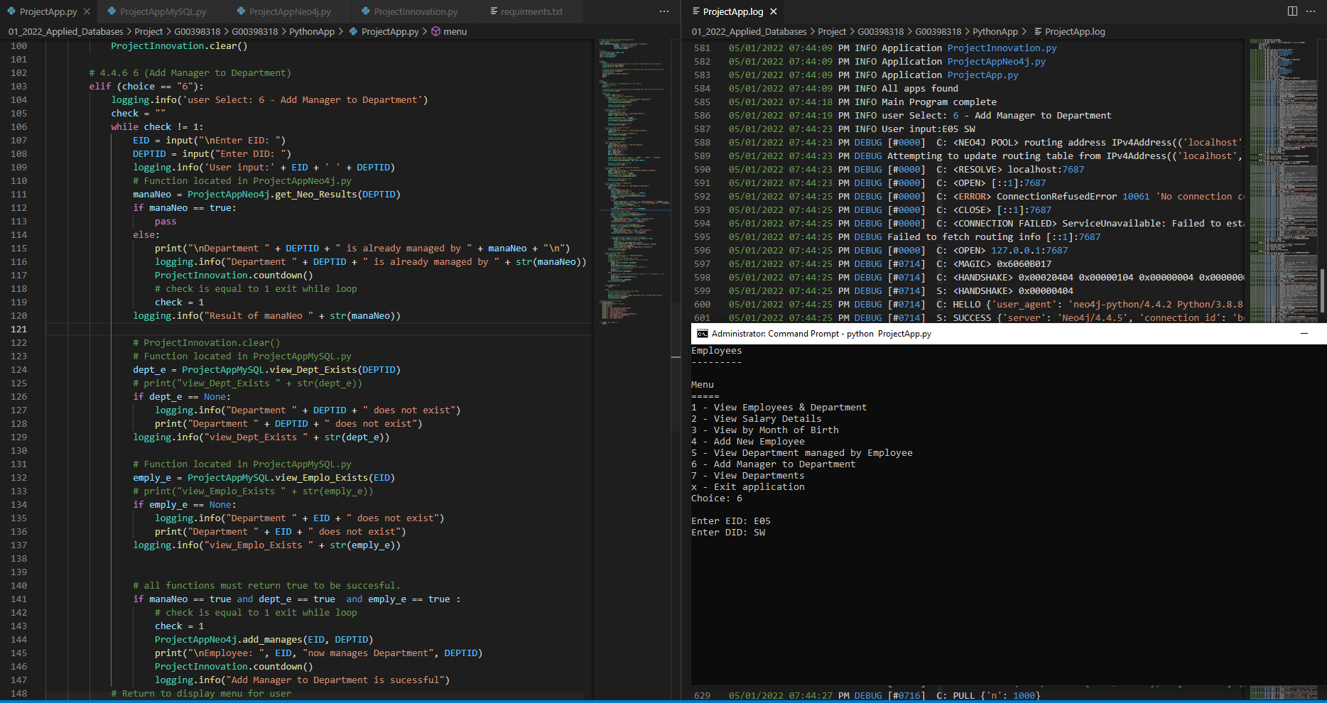

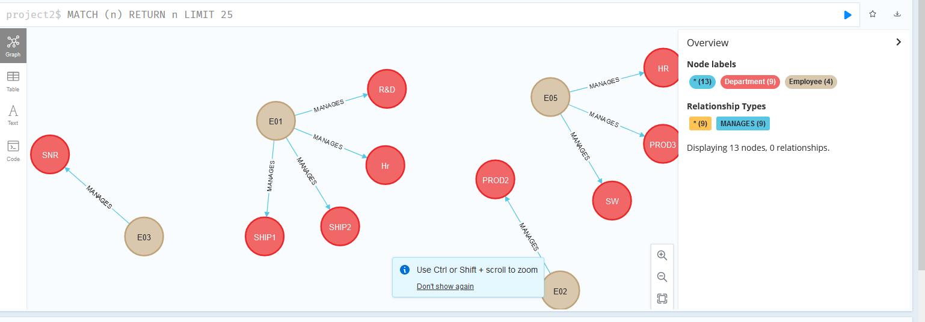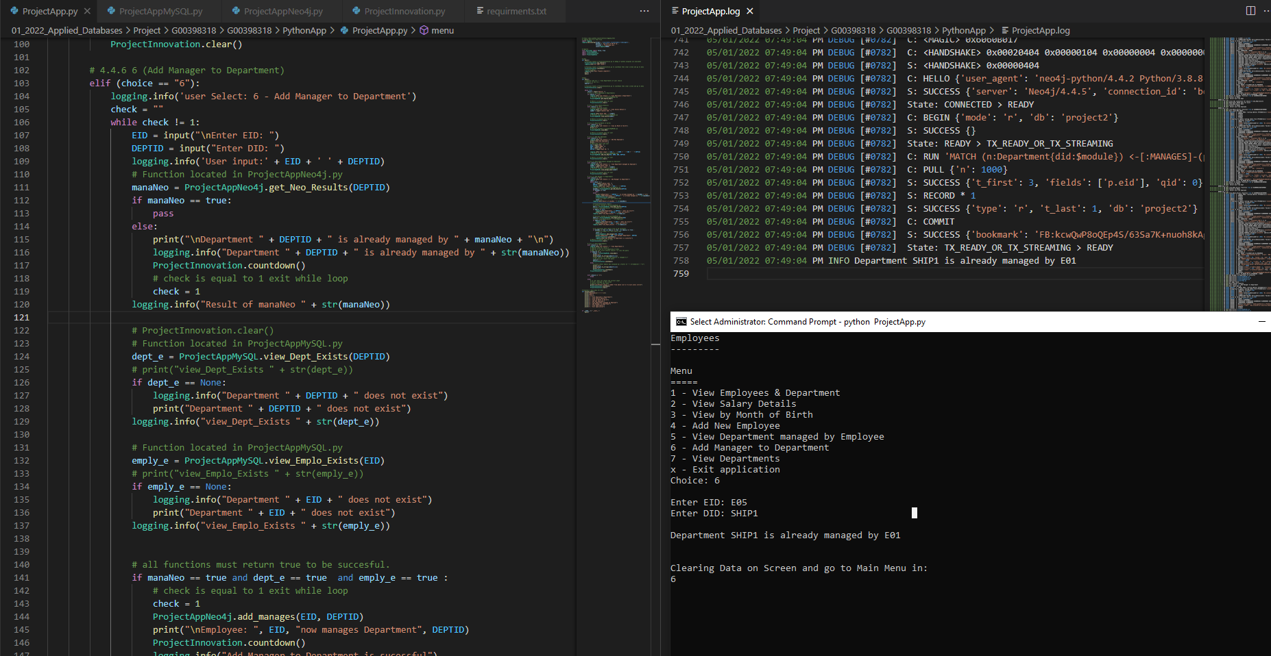

*Department already managed by*

*Employee and department does not exist*

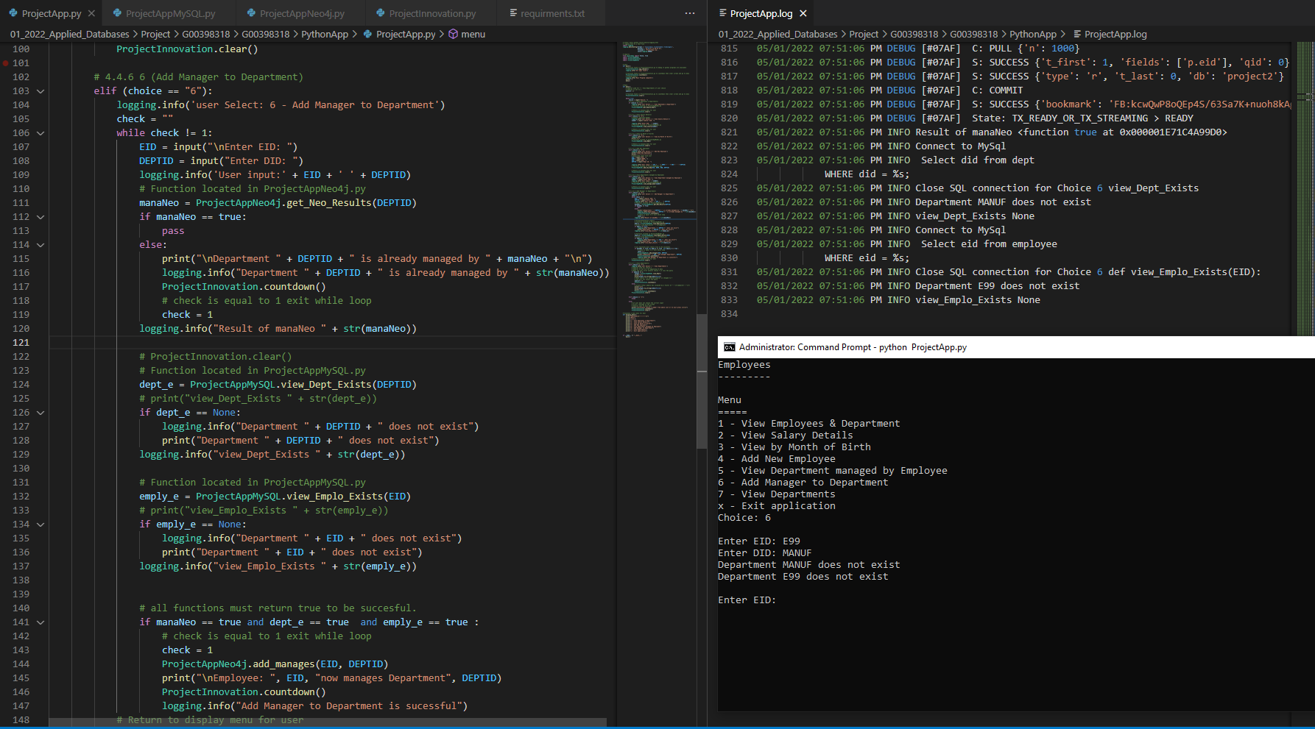

*##############################################################################*

*Choice 7*

*Table called from memory*

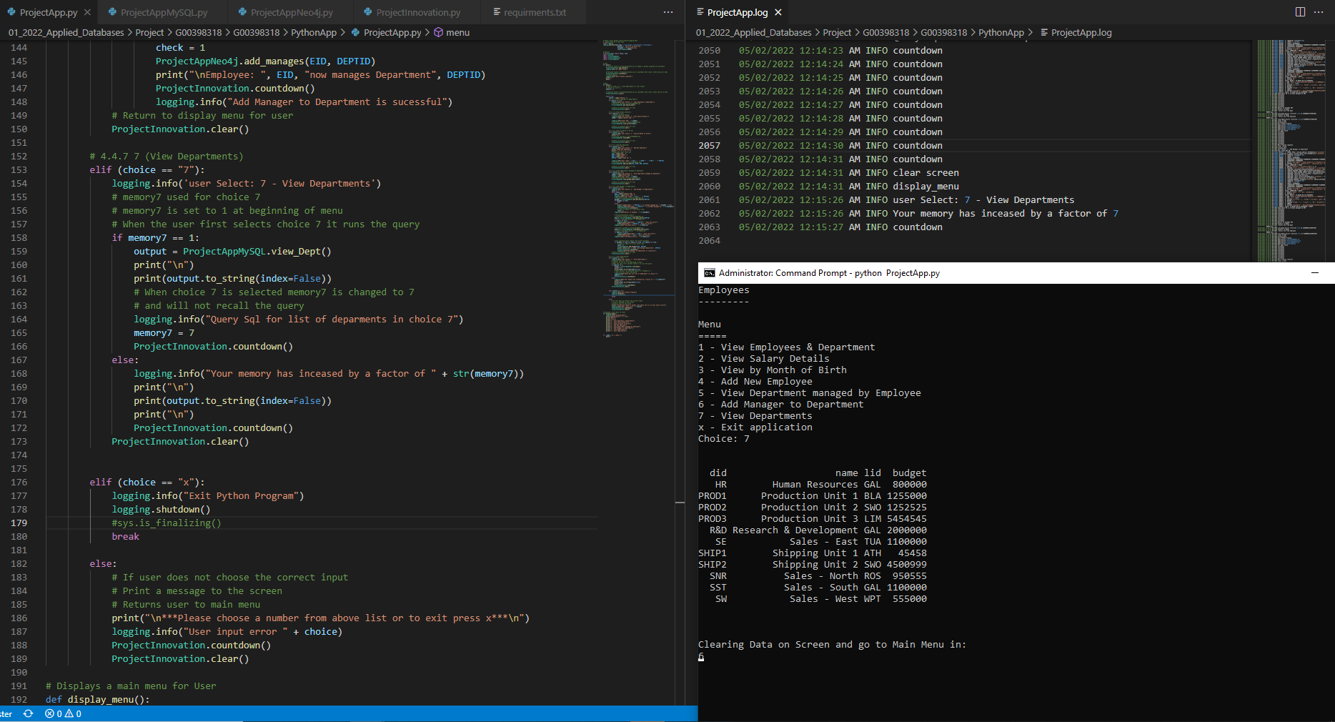

*##############################################################################*

*Does not recreate on every time program is run*

*Possible error if exit program after choice 6*

*Error on exit for logging for a known issue with Python finalisation*

*"NameError: name 'open' is not defined" when logging really late during the Python finalization*

*https://bugs.python.org/issue26789*

*https://pythondev.readthedocs.io/finalization.html*

